# High Level MLOps Continuous Deployment

## Specific instructions for the project

In this project, the goal is for you to build use a high-level App Deployment like [AWS App Runner](https://aws.amazon.com/blogs/containers/introducing-aws-app-runner/) and deploy it automatically. Note that AWS App Runner is the most straightforward way to accomplish this goal and is recommended.

Note if you are more familiar with GCP or Azure you can instead use those platforms using Azure App Services or GCP options including [*Google App Engine*](https://github.com/noahgift/gcp-flask-ml-deploy)

Use the starter code in the [*Python MLOps Cookbook*](https://github.com/noahgift/Python-MLOps-Cookbook) or your own code.

### ****Your Tasks****

1. Launch [*AWS CloudShell*](https://aws.amazon.com/cloudshell/), environment and setup the project by forking the sample code. Other examples of Cloud environments include [*AWS Cloud9*](https://aws.amazon.com/cloud9/), [*Github Code Spaces*](https://github.com/features/codespaces), [*Google Cloud Shell*](https://cloud.google.com/shell), or [*Azure Cloud Shell*](https://docs.microsoft.com/en-us/azure/cloud-shell/overview).
2. Setup AWS App Runner Project as shown in the steps. Be sure to put the appropriate build command. One example include pip install -r requirements.txt

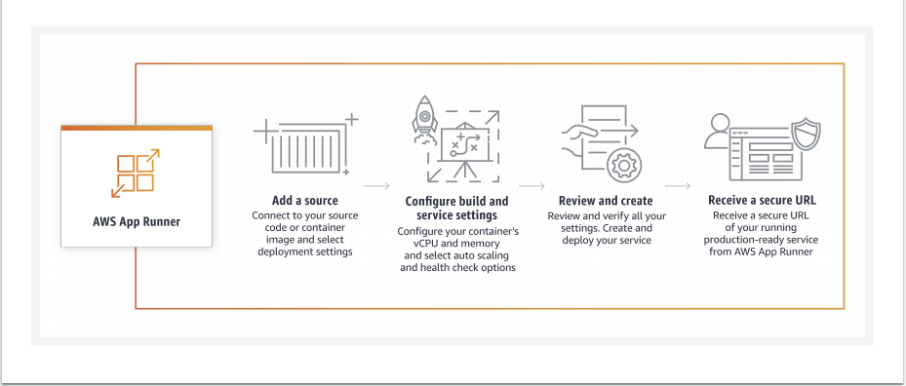

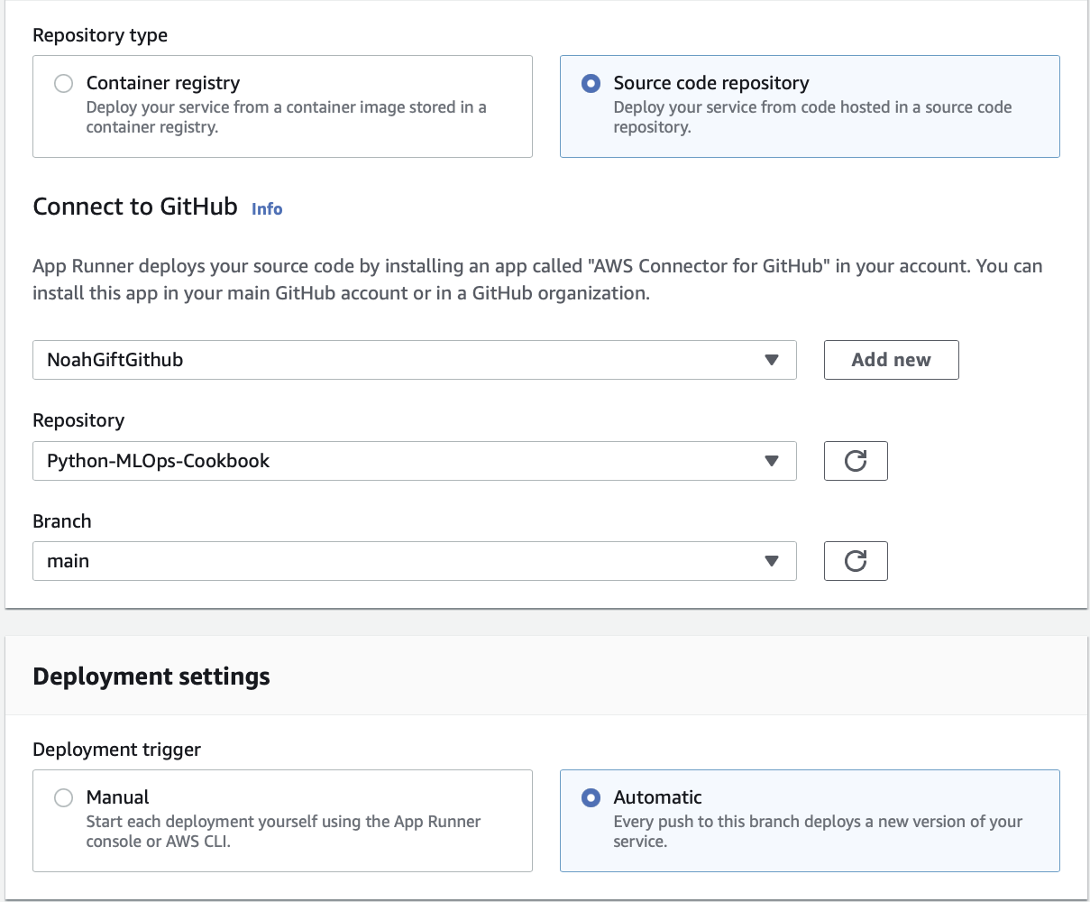

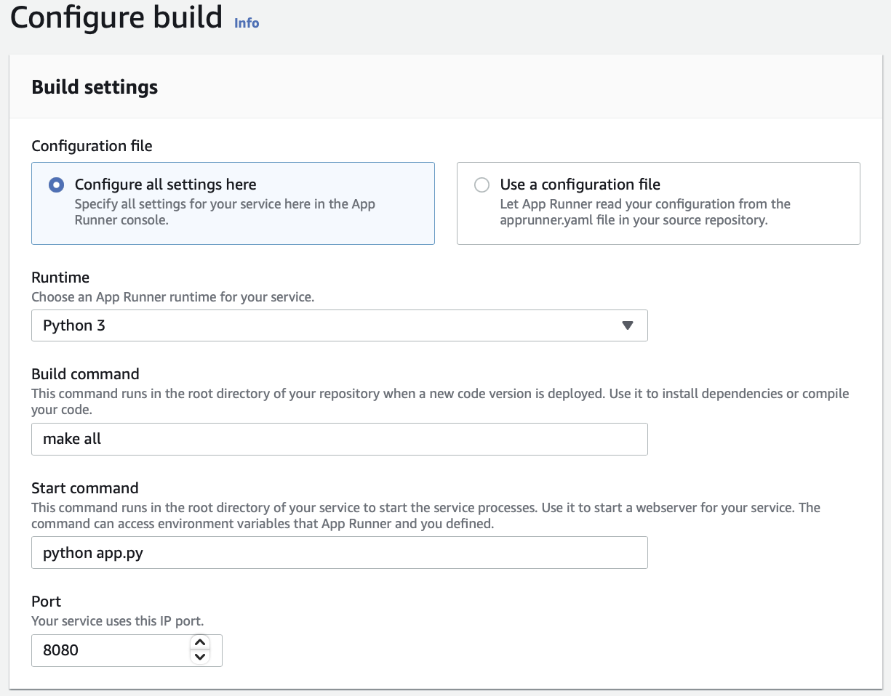

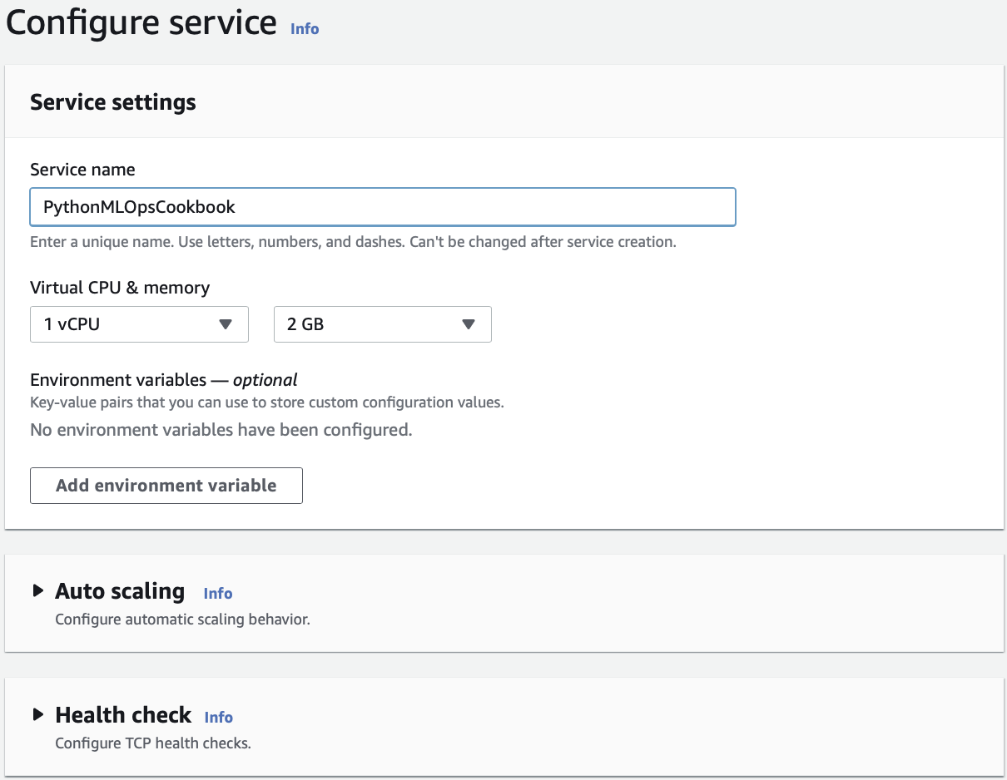

1. Get the project going to install, lint and test via GitHub Actions.
2. Test making changes on more than one Cloud Development environment.
3. Create a Demo project in GitHub with a README.md that describes what you did.
4. Create a Demo Video and reference it in your GitHub Project.
5. (Optional) Share your portfolio project on Social Media with the hashtag: #duke-cloud-computing-for-data.

### Sample Deliverables

* **Demo video**. Follow the example in the lesson Video [good example video showing Azure with Github Actions.](https://youtu.be/rXXtJpcVems)
* **GitHub repo**. Here is a [complete example of the Github repo](https://github.com/noahgift/azure-ml-devops) you can build with the YouTube Video inside.